Concepts:

General Notes:

* "<li class = \"selected\">"; here /" is used for escape the double quotes i.e it's not the closing double quote.
* Content Management System
* “CMS” for short
* Public views content(read-only)
* Admins edit content
* CRUD: create, read, update, delete

Build a CMS follow the following steps:

* Start by creating a project blueprint
* Draw diagrams or type up notes
* Clarifies work ahead
* Confront problems early
* Develop section-by-section
* To develop a cms follow the following steps:
* First draw the whole project
* Second make data modeling of the whole project
* And finally creating table in database.
* Edit combines both create and read.
* For doing editing prepopulate the data from the database.
* We can track the id by using hidden field in the form and another way is passing id using the query string.

Generally websites contain following two areas:

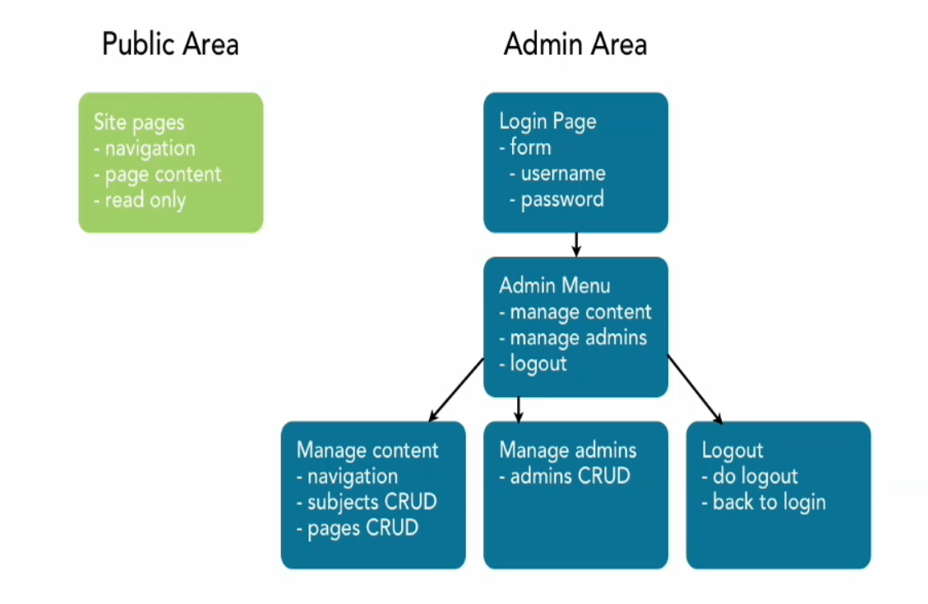

* Admin area can be password protected area which can be goes to public area.

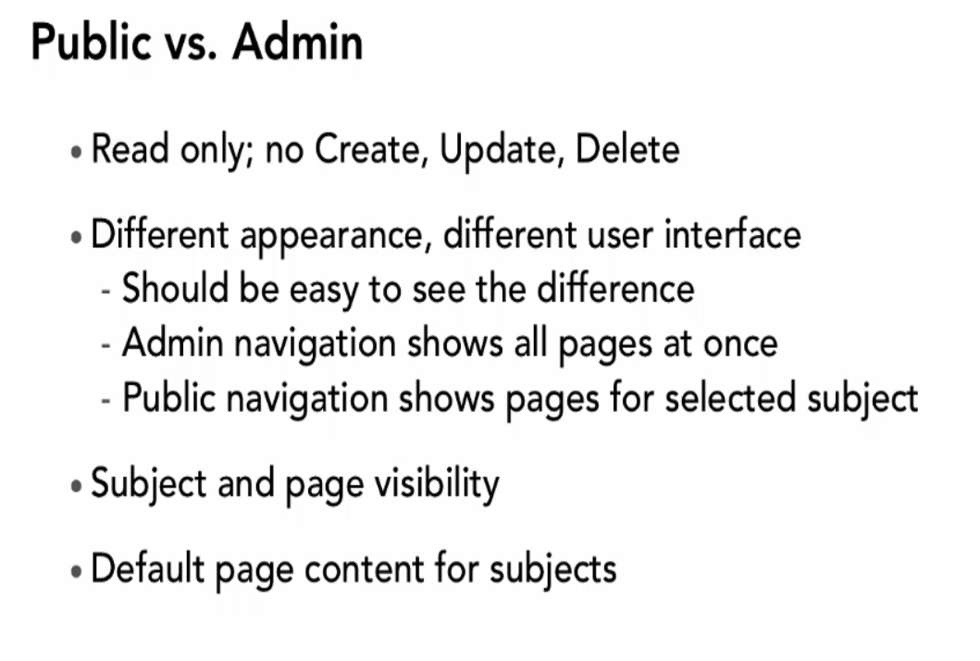

* Data modeling is help out to mapping the application with the database following modeling is our applications data modeling.

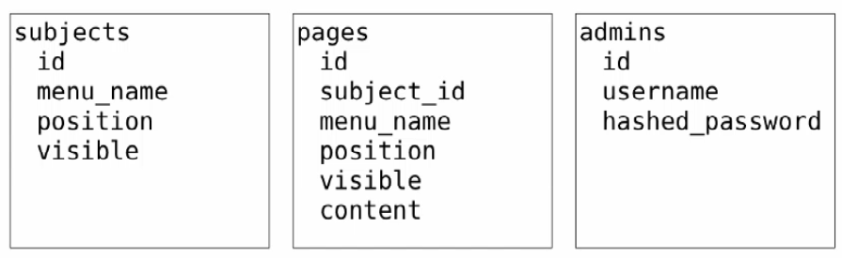

* .. means parent directory and . means previous directory.
* Code Refactor: Revising existing code to change its structure or appearance without changing its behavior.
* Code Re-factoring: improve code quality without changing any function or code.

Revise code for following advantages:

* Simplicity
* Clarity
* Maintainability
* Efficiency
* Flexibility
* Reusability
* Extensibility
* Functions are the great way for refactoring code.
* Passing a direct id is not good programming as the parameter.
* Delete
* In the case of delete if the table belongs to anther table it will be safer if we delete first the content all belongs table for more safety.
* Another way is delete master table contain which will privilege to delete all belongs table content. It will be more destructive.
* Any output or anything in html even come from trusted source like database or others we need use htmlentities or htmlspecialchars in the case of string for escaping string.
* Anything output of string in html we must ensure safety.
* Anything part of URL string we must use urlencode even we feel very safe about it.

Using Context for Conditional Code

* Example:

$context = ‘day’;

If ($context == ‘night’) {

Echo “Talk Quietly.”;

} else {

Echo “Talk normally.”;

}